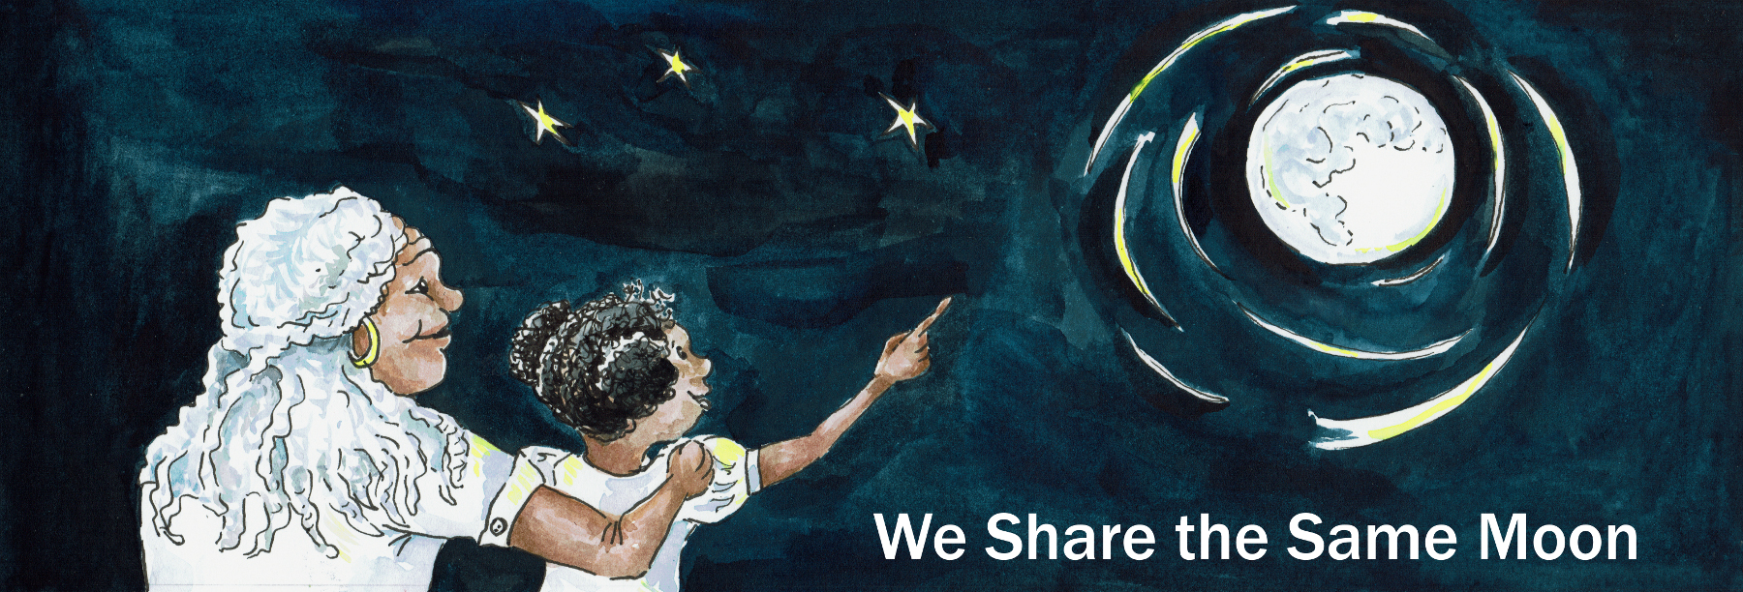
Suggested Age Range: 7- 8 years: 8 - 9 years
UK Curriculum: Key Stage Two
Suggested UK Year Group: Year 3
UK Primary Curriculum Link: Light
Science Subject: The Sun
Science Question: Why does the Sun hurt our Eyes?
Suggested Science Activity: Sun Viewer
Children with SEND: Use to boost comprehension of science vocabulary
EAL children: Beginners Level
Country of Origin: China
Source: Tales of the Sun and Moon by Lynn Moroney;
Tales of a Chinese Grandmother by Frances Carpenter

Long ago, when the world began, according to the people of China, the Sun, and the Moon and the Earth were created in the Sky.
On the Earth, lived all the different people, in their different countries around the world.

But …

On the Sun, there lived a Prince, in a golden palace, and on the Moon, there lived two Princesses, in a silver palace.

Now, the Prince, he liked nothing more than to sit all day, looking around him.
But the Princesses, they worked, they had a job to do.

They sat all night, stitching a beautiful picture of what they saw down on the Earth below. They stitched night after night, every night, all night long.
They stitched a giant picture, out of thousands and thousands of strands of silk thread. Everything looked exactly like it did on Earth.

They stitched and they stitched and they stitched, so carefully, they got every tiny detail - just right!

When they stitched the trees, they stitched the shape of the trunk, the length of the branches and the numbers of the leaves, just right.

When they stitched the flowers, they stitched the shape of the petals, the length of the stem and the number of leaves, just right.

When they stitched the grass, they stitched the shape, and the colour and length of each and every blade of grass, just right

Everything they stitched, they stitched, just right!

But it was hard work and needed a lot of concentration to make sure their picture was perfect.

But, there was a problem! Uh oh!

And what was the problem? The people living down on the planet Earth!
During the day, the people were too busy working to look up at the Sky.
But, at night, when their work on Earth was complete, they would sit and look up at the Sky and THAT is when the problem began!

One person would peer, up at the Moon, see the two Princesses at work, stitching their picture. They would stand up to get a better view and then, they would tell everyone else what they saw.

“Oh my goodness! There are two Princesses on the Moon!’
“Oh my goodness! They are stitching a giant picture of the Earth!
“Oh my goodness! It looks exactly like the Earth!”
“Oh my goodness, just look at those trees! They have got the trunks, and the branches and the leaves just right! Oh do come! Do come and have a look!”

And so of course, the next person would stand up, have a look and tell some-one else. Who would, stand up, have a look and tell someone else, who would stand up, have a look and …

So, all over the Planet Earth, people would be looking up at the Moon and talking about what they saw.

At first, the Princesses liked having an audience.

But, As their audience got bigger and bigger, and bigger, the noise from those watching, got louder and louder and louder!
The poor Princesses found it harder and harder and harder to concentrate on their work.

What to do?

They talked to their brother and together they made a cunning plan.
Late at night, whilst their audience was asleep ….
The brother and the two sisters switched places and palaces!
He came to live on the Moon and they moved to live on the Sun!
At first the people down on Earth were puzzled. Where have the two Princesses gone?

But …

One day, someone saw them in their palace on the Sun!
They turned to look directly at the Sun, and, the Princesses were ready!
They picked up their needles and stabbed them in the eye!
OUCH! The person looked away in a hurry!
The next day, someone else turned to look directly at the Sun and OUCH!
They were too were stabbed with a needle!
And another person and another person were stabbed with a needle- OUCH, OUCH!
And other and another and another … OUCH, OUCH, OUCH, OUCH, OUCH!

From that day on, the people on Earth learned a very. painful lesson.
NEVER EVER look directly at the Sun.
And so the Princesses were left to stitch their picture in peace.

But, just in case, someone looks up at the Sun,
They are always ready with their needle to stab. OUCH!
And that is why, you should never ever, look directly at the Sun,
just in case you get stabbed in the eye by a bad-tempered princess!

Or at least that is what they say in China.

But, scientists say it is the heat from the Sun, that burns our eyes.

Which is why you must never, ever look directly at the Sun.
But … what do you think is true?

Retold by Cassandra Wye, Copyright; April 2019

